Houses4Autism  Newsletter  Final Conference Dublin |  | 

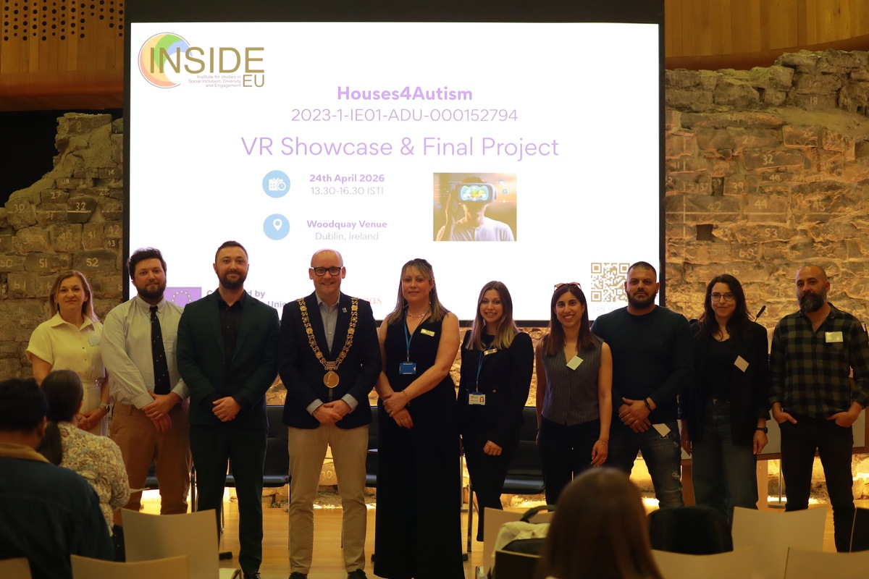

Consortium partners and the Lord Mayor of Dublin, Cllr Ray McAdam, at the Houses4Autism Final Conference, The Woodquay Venue, Dublin, 24 April 2026.

About the Event  On Friday 24 April 2026, INSIDE EU — the Institute for Studies in Social Inclusion Diversity and Engagement — hosted the final conference of the Houses4Autism Erasmus+ project at The Woodquay Venue in Dublin.  Titled Innovation & Inclusion in Action, the event brought together EU consortium partners (Stando, Voice for Autism, Blue Firefly), policymakers, researchers, educators, autistic adults, and their families to celebrate three years of collaborative, EU-funded work focused on supporting independent living for autistic adults.  Central to the day was the showcase of the project's virtual reality (VR) training tool; an immersive, purpose-built environment designed to help autistic adults develop everyday living skills in a safe, low-anxiety setting.  Opening & Key Speakers  The conference was formally opened by the Lord Mayor of Dublin, Cllr Ray McAdam, who described the project as innovation at its best: human-centred, purpose-driven, and inclusive by design. He referenced Dublin City Council's recently launched three-year Autism Friendly City Strategy and spoke of VR as a genuine tool for empowerment; not a gimmick, but a means of building confidence and removing barriers to full participation in civic and community life.  Deputy Rory Hearne TD attended and contributed insights on the critical link between autism, housing instability, and homelessness risk; drawing on recent cases to underscore the urgency of the policy challenges the project addresses.  Jemma Lee of Leargas, Ireland's national Erasmus+ agency, also attended and spoke, reflecting the project's significance within the wider adult education landscape. |  | Main Outcomes  Three years of EU-funded collaboration produced a substantial suite of freely available outputs:  - An evidence-based international research report on the status of supportive housing for individuals with autism  - A comprehensive curriculum for adult educators  - A handbook for adult educators  - A VR game with interactive scenarios simulating real home environments  - A train-the-trainer course for adult edicatprs  All outputs will be made freely available on the INSIDE EU website in the coming weeks, in line with Erasmus+ open access requirements.  Ministerial Support  Minister for Children, Disability and Equality, Norma Foley TD, was unable to attend in person but contributed a written message of support; describing the project as a welcome example of harnessing new technologies and working with EU partners to make a meaningful difference for disabled people.  Her message also paid a warm personal tribute to the late Dirk van der Merwe, whose legacy was felt throughout the day.

Funded by the European Union. Views and opinions expressed are however those of the author(s) only and do not necessarily reflect those of the European Union or the European Education and Culture Executive Agency (EACEA). Neither the European Union nor EACEA can be held responsible for them.

Houses4Autism  Newsletter  Final Conference Dublin |  | Houses4Autism

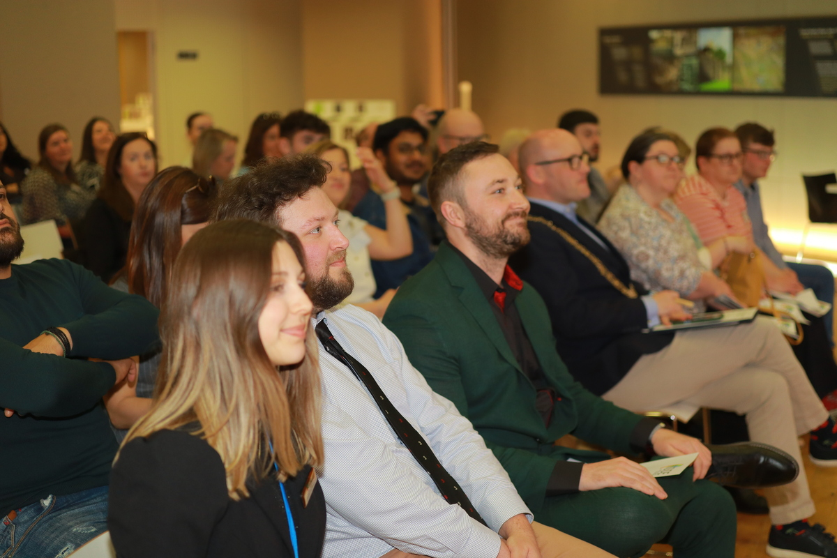

Attendees at the Houses4Autism Final Conference, The Woodquay Venue, Dublin.

Key Research Findings  INSIDE EU's original international research, gathered across consortium partner countries, revealed a striking and persistent gap between the educational attainment and independent living outcomes of autistic adults:  - 55-82% of autistic adults hold third-level qualifications  - Yet only 14-45% of autistic adults live independently  - Just 5% live alone; 65% continue to live with family  - 100% of respondents called for improved autism training for professionals  These findings underscore a systemic disconnect between formal educational achievement and the practical, social, and environmental conditions needed to support autonomous living.  They will inform INSIDE EU's advocacy and policy engagement at national and European level, and are embedded in the design of the project's VR training tool and educational curriculum. |  | What Comes Next  Following the conference, INSIDE EU is focused on translating the project's findings into sustained impact; engaging with policymakers, informing national and EU-level debates on autism, independent living, and disability inclusion.  As a neurodivergent-led non-profit, INSIDE EU is also expanding its delivery offer; launching Department of Education-approved CPD summer courses for primary school teachers this year, alongside continued development of multi-sector inclusion training grounded in the Houses4Autism research.  INSIDE EU and the project consortium look forward to continuing to work with partners, policymakers, and practitioners who share a commitment to inclusion. To learn more, access the educational toolkit, or explore collaboration opportunities, visit:  www.insideeu.eu  Erasmus+ Project Reference: 2023-1-IE01-KA220-ADU-000152794

Funded by the European Union. Views and opinions expressed are however those of the author(s) only and do not necessarily reflect those of the European Union or the European Education and Culture Executive Agency (EACEA). Neither the European Union nor EACEA can be held responsible for them.

Houses4Autism  Newsletter  Final Conference Dublin |  | Houses4Autism

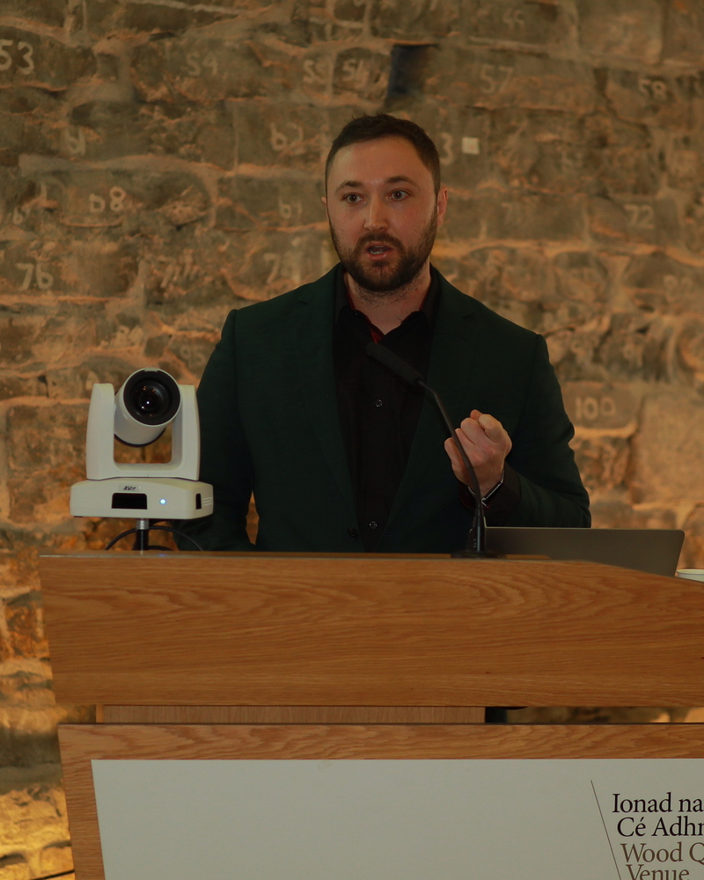  Christian Sweeney, CEO of INSIDE EU, addresses the conference from the Woodquay Venue podium. |  | 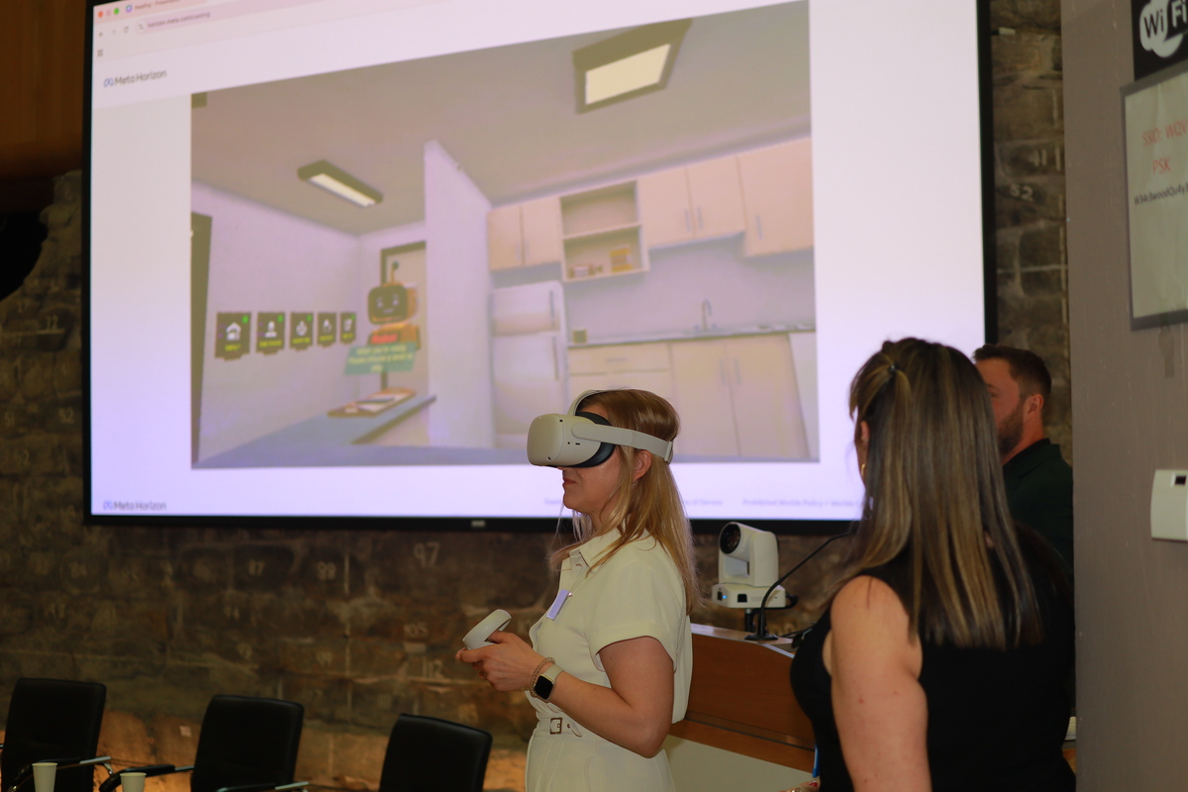  Showcase of the VR game supporting the acquisition of independent living skills

The VR Showcase  One of the highlights of the day was the opportunity for attendees to experience the Houses4Autism VR training tool first-hand. Developed in partnership with consortium members, the tool immerses autistic adults in simulated home environments — from the kitchen to the living room — where they can practise everyday tasks at their own pace, in a calm and supportive setting.  The response from delegates was enthusiastic; many noting that seeing the tool in action brought the research findings to life in a way that no presentation alone could achieve. |  | In Memory of Dirk van der Merwe  The conference was dedicated in part to the memory of the late Dirk van der Merwe; a cherished colleague and steadfast supporter of INSIDE EU whose warmth, commitment, and advocacy for the communities INSIDE EU serves left a lasting mark on all who worked alongside him.  His legacy was woven throughout the day's proceedings, and was warmly acknowledged in Minister Foley's written message. He is greatly missed by the entire team, and the work of Houses4Autism stands as a testament to the values he embodied.  Follow Us  Stay up to date with INSIDE EU's work and the ongoing dissemination of the Houses4Autism outputs:  www.insideeu.eu

Funded by the European Union. Views and opinions expressed are however those of the author(s) only and do not necessarily reflect those of the European Union or the European Education and Culture Executive Agency (EACEA). Neither the European Union nor EACEA can be held responsible for them.

